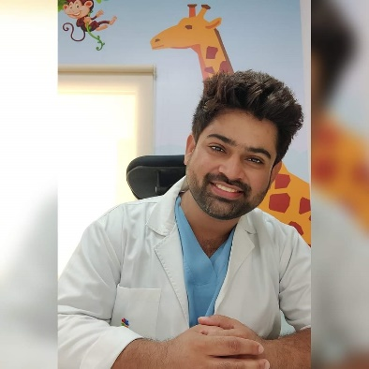

Dr. Kunal Chawla
MBBS, DCH, DNB (Pediatrics)
Own Practice at Ulhasnagar, Thane
“Chawla’s Kiddy Care Clinic”

