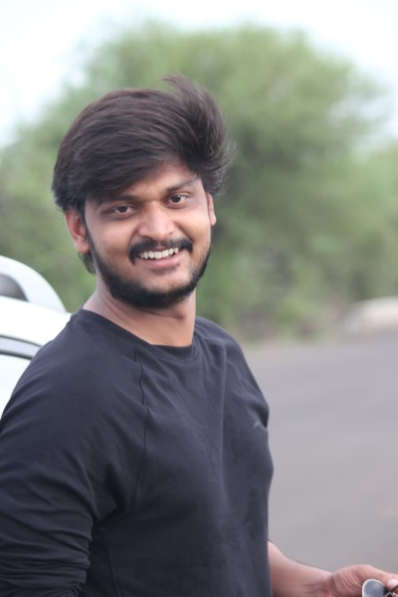

Dr. Prashant Haridas Khatal
MBBS,
MD (Anaesthesiology) at
Dr. Vaishampayan Memorial Govt. Medical College, Solapur

