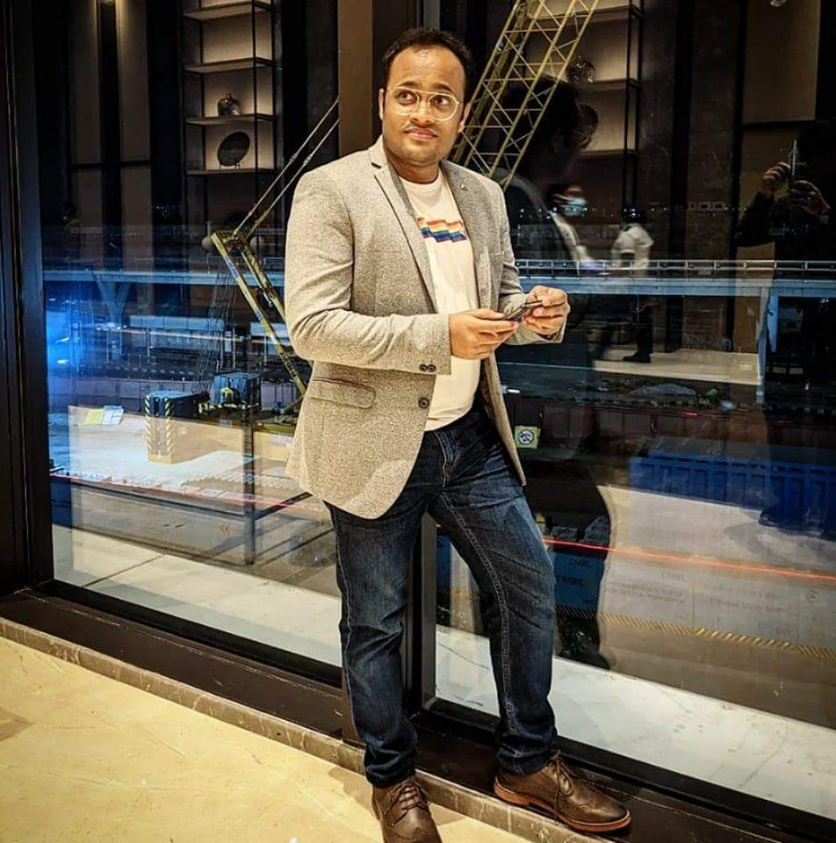

Dr. Mangal Rachate
MBBS
MS (General Surgery)
DNB (Neurosurgery)

