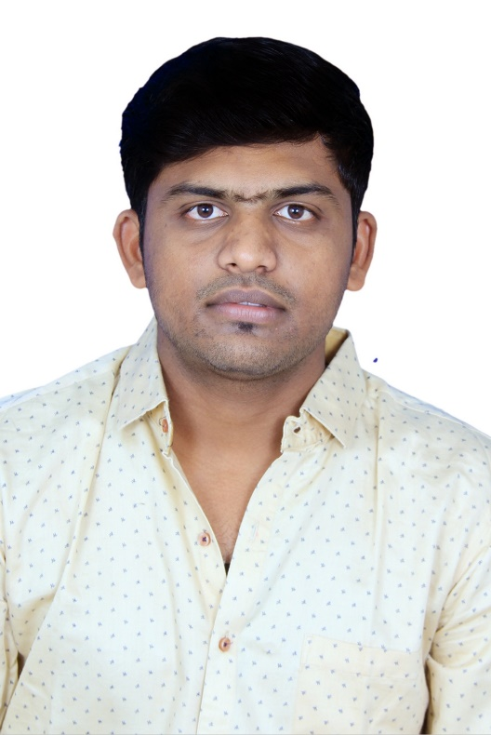

Dr. Mahesh Harishchandra Hamand
MBBS
MD (Community Medicine) from
Govt Medical College, Latur

