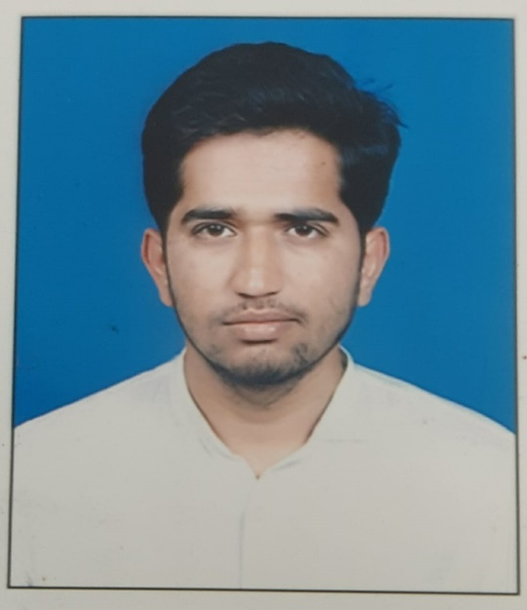

Dr. Kiran Lalasaheb Nagargoje
MBBS
MD (General Medicine) at Jorhat Assam

