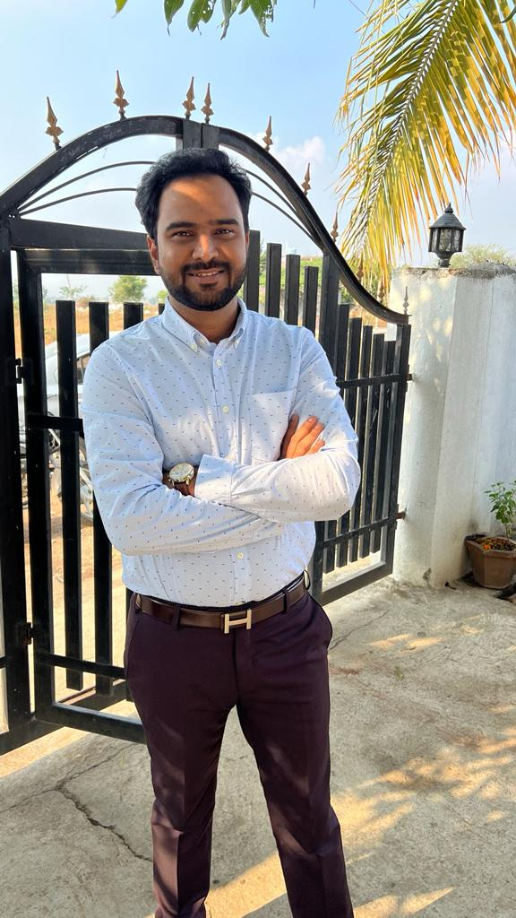

Dr. Akshay Kishanrao Nalabale
MBBS
MD (Community medicine) at
Dr. Shankarrao Chavan Govt. Medical College, Nanded

