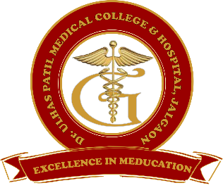
Godavari Foundation’s
DR. ULHAS PATIL MEDICAL COLLEGE & HOSPITAL,
Recognized by Medical Council of India, Approved by Central Govt. of India, New Delhi,
Letter no. MCI-34(41)/2012-med./158127, dated 05/02/2013
Affiliated to Maharashtra University of Health Sciences, Nashik [College Code-1306]
Jalgaon-Bhusawal Road, NH-6, Jalgaon Kh, Tal. & Dist. Jalgaon 425309
Tel. No. (0257)2366657, 2366678 Fax No. 0257-2366648
Email ID : dupmcj@yahoo.in Web Site : www.dupmc.ac.in

5.4.1 The Alumni Association is registered and holds regular meetings to plan its involvement and developmental activates with the support of the college during the last five years.
The institute has turned out a significant number of graduates over last decade and its alumni are spread across the country, with few also internationally. The institute very much still considers its alumni to be a part of the family.
Institute has registered the alumni association with registration number Jalgaon/0000228/2022.
The alumni association cell has been setup in the institute with the intention of strengthening the alumni activity. We have a working alumni portal that helps the alumnus and the institute to get in touch with each other. Using the portal, the alumnus can get information about institute, fellow colleagues, seniors, juniors, alumni meets and conferences. The portal also features success stories of alumni.
Regular activities of alumni association are:
- Regularly keeping the Alumni portal updated with all relevant information of Alumni and institute.
- Providing alumni information to other alumni for academic development.
- Involving alumni in conducting guest lectures, workshops based on their experience.
- Organizing annual alumni meet and awarding alumni with Distinguished Alumnus Award.
- Inviting alumnus contributions for the development of institution.

