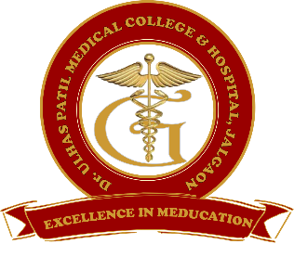  222 | Godavari Foundation’s  DR. ULHAS PATIL MEDICAL COLLEGE & HOSPITAL,  Recognized by Medical Council of India, Approved by Central Govt. of India, New Delhi,  Letter no. MCI-34(41)/2012-med./158127, dated 05/02/2013  Affiliated to Maharashtra University of Health Sciences, Nashik [College Code-1306]  Jalgaon-Bhusawal Road, NH-6, Jalgaon Kh, Tal. & Dist. Jalgaon 425309  Tel. No. (0257)2366657, 2366678 Fax No. 0257-2366648  Email ID : dupmcj@yahoo.in Web Site : www.dupmc.ac.in

6.4.2 Title:- Institution conducts internal and external financial audits regularly.
Response:- Dr. Ulhas Patil medical college has a mechanism for Internal and external audits. Our institute carried out Internal and External audits regularly.
Internal audit
Our college has its own internal audit mechanisms.
Internal audit is carried out by the head of the account department.
A team of account staff under the guidance of the head of the account department check and verify of all transactions that are carried out in each financial year.
The purpose of an Internal Audit is to review the routine activities of the business and also give suggestions for improvement.
External audit
We follow Mercantile Accounting System.
The external audit is carried out by Charted Accountant appointed by the Institute.
It is carried out once in a financial year.
It checks all the expenditures of infrastructure development, operating expenses, teaching, and non-teaching staff salary. Charted Account also checks TDS on salary as well as party payment (Like Contractor Payment, Service Provider Payment and Professional Payment).
It also verifies the income of the institute which is earned from student fees and hospital income.
The final audit report of the institute is prepared by an external auditor and submitted to the income tax department Charity Commissioner Office every year within the stipulated time.

An error has been also found out during the audit procedure, but it will be rectified accordingly.
The external audit report is maintained in the account office of the institute.

Chairman Dean
Dr. Ulhas Patil Medical College Dr. Ulhas Patil Medical College
& Hospital, Jalgaon Kh & Hospital, Jalgaon Kh

