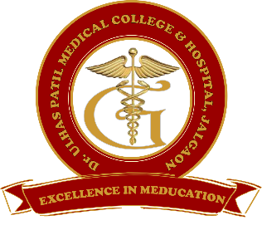 | Godavari Foundation’s  DR. ULHAS PATIL MEDICAL COLLEGE & HOSPITAL,  Recognized by Medical Council of India, Approved by Central Govt. of India, New Delhi,  Letter no. MCI-34(41)/2012-med./158127, dated 05/02/2013  Affiliated to Maharashtra University of Health Sciences, Nashik [College Code-1306]  Jalgaon-Bhusawal Road, NH-6, Jalgaon Kh, Tal. & Dist. Jalgaon 425309  Tel. No. (0257)2366657, 2366678 Fax No. 0257-2366648  Email ID : dupmcj@yahoo.in Web Site : www.dupmc.ac.in

6.2.1 The Institutional has well defined organisational structure, Statutory Bodies/committees of the College with relevant rules, norms and guidelines along with Strategic Plan effectively deployed. Provide the write-up within 500 words
Dr. Ulhas Patil Medical College and Hospital is committed to impart quality education to medical graduate and postgraduate with development of their right attitude, professional competence and right ethical values. We have formerly developed quality polices, strategies etc.
A strategic plan was planned in January 2018 under the guidance of Dean to improve the quality of teaching and patient care. The responsibilities for the deployment of strategic plan are assigned by Dean of the college. Dr. Ulhas Patil Medical College has a well-defined organization structure for effective deployment and implementation of strategic plan. Organization structure is formed and implemented in the institute.
Meetings of college council are held regularly and decisions made by its members are then circulated to relevant committees for the deployment of decisions. The college council is headed by dean of the institute and all departmental heads are the members of it. This council reviews all academic and administrative activities.
To ensure the development of the college, all planning and execution are monitored regularly. Strategic plan is developed for institutional development.

Following are the future plans –
- To increase intake of students from 150 to 250 for MBBS.
- To gradually improve the infrastructure parallel to intake of students.
- Renovation of cathlab.
- To provide bus facility for non-teaching staff
- To develop library software
- To take CISP implementation programme for new CBME syllabus
- To establish RTPCR lab.
- To get NABL accreditation of RTPCR lab.
- To do NAAC Accreditation of the institute.
- To establish green campus.
- Installation of oxygen plant.
- To establish skill lab
- To do NABL of CCL lab.
- To do NABH accreditation of Hospital.

The Institute has MEU, IQAC, and various committees for maintaining and monitoring of strategic plan and its deployment.

Dean Chairman
Dr. Ulhas Patil Medical College Dr. Ulhas Patil Medical College
& Hospital, Jalgaon Kh & Hospital, Jalgaon Kh

