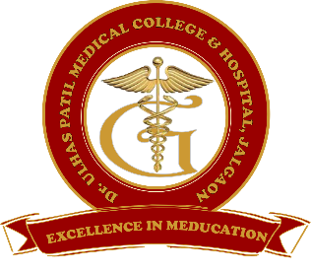 | Godavari Foundation’s  DR. ULHAS PATIL MEDICAL COLLEGE & HOSPITAL,  Recognized by Medical Council of India, Approved by Central Govt. of India, New Delhi,  Letter no. MCI-34(41)/2012-med./158127, dated 05/02/2013  Affiliated to Maharashtra University of Health Sciences, Nashik [College Code-1306]  Jalgaon-Bhusawal Road, NH-6, Jalgaon Kh, Tal. & Dist. Jalgaon 425309  Tel. No. (0257)2366657, 2366678 Fax No. 0257-2366648  Email ID : dupmcj@yahoo.in Web Site : www.dupmc.ac.in
4.4.2 Institution frequently updates its IT facilities and computer availability for students including Wi-Fi
- The institution has adequate ICT facilities available for teaching-learning activities of students.
- Institution is well equipped with computers for improvement of quality of students teaching – learning process.
- Institution has E – library with adequate numbers of computers with internet connectivity for the use of students and staffs.
- The digital library has computers connected to internet for the e-journals subscribed by college through K-HUB to access PubMed and e-content resources like SWAYAM, NPTEL etc.
- With 100 mbps broadband line from SCUD communication private limited,Jalgaon , institute has provided uninterrupted internet facility with high speed CAT6 cable to every departments.
- All computers and audio-visual equipment are supported by UPS/generator.
- Computers facilities are also made available to students for academic, projects and research activities.
- Each department has computer facility and is connected through LAN.
- Network security is ensured through Firewall subscriptions (TUX WALL).
- Antivirus is installed in all computers to prevent, detect and remove viruses. Antiviruses are regularly updated to prevent entry of virus into system.
- Lecture halls are fully upgraded with ICT facilities with LCD projectors and laptops for the effective delivery of lectures in terms of PowerPoint presentations, online videos for demonstrating various invasive procedures, etc.
- For enhances operative clinical teaching, the institute provides live transmission, recording and broadcasting of operative procedures from our operation theatres to classroom for our undergraduate and postgraduate students.
- For the safety of students and staff, entire campus is monitored through CCTV cameras.

Dean
Dr. UlhasPatil Medical College & Hospital, JalgaonKh

