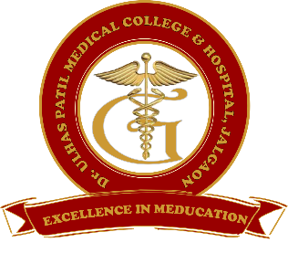 | Godavari Foundation’s  DR. ULHAS PATIL MEDICAL COLLEGE & HOSPITAL,  Recognized by Medical Council of India, Approved by Central Govt. of India, New Delhi,  Letter no. MCI-34(41)/2012-med./158127, dated 05/02/2013  Affiliated to Maharashtra University of Health Sciences, Nashik [College Code-1306]  Jalgaon-Bhusawal Road, NH-6, Jalgaon Kh, Tal. & Dist. Jalgaon 425309  Tel. No. (0257)2366657, 2366678 Fax No. 0257-2366648  Email ID : dupmcj@yahoo.in Web Site : www.dupmc.ac.in

4.3.2 Total number of textbooks, reference volumes, journals, collection of rare books, manuscripts, digitalized traditional manuscripts, Discipline-specific learning resources from ancient Indian languages, special reports or any other knowledge resource for library enrichment
Godavari Foundation’s Dr Ulhas Patil Medical College has established well equipped library having textbooks, reference volumes, journals, collection of rare books, manuscripts, Digitalized traditional manuscripts, Discipline-specific learning resources from ancient Indian languages, special reports or any other knowledge resource for library enrichment
Following learning resources has enriched Institutes library –
- Reading Room : The Central Library has specious reading room area with 590 seating capacity for the UG and PG students and 40 seats for staff reading. The reading room facility available for 18x7x365 for students.
- Textbook : There are more than 10134 latest edition textbooks available in the library.
- Reference books : There are 559 reference books available in the library.
- Journals : Godavari Foundation’s central library regularly subscribed well reputed Indian as well as International journals.
- CD / DVD : There are 158 CD’s and Dvd’s available in the library.
- E-library : Central library has well equipped e-library with 60 computers and it was connected by 100 mbps internet speed. Students and staff can browse the internet facility and they are controlled by firewall system.
- Digitalized Manuscripts: ‘lipi’ Medical digital manuscripts collection is a part of k.hub.in e-library services which is subscribed by the institute. It is focused on delivering various manuscripts content to its users. There are more than 16000 records, rare and ancient books ranging from 1000 B.C.E.
All the records are searchable and downloadable for all users. The users can search originals, handwritten and typewritten manuscripts from over 7 different languages.

